# Assignment 2

## Due Date:

Softcopy: 1st March, 2020, Sunday, at 11:59PM.

Hardcopy and Demo: The first day your class takes place after the softcopy is due. Check the course Calendar in eConestoga under Content->Course Information->Schedule Summary.

## Topic:

Enhance the prototype created in Assignment 1 with jQuery validation. This version will be used in the next assignments.

## Before you begin:

* You must complete Assignment 1 before proceeding.
* You must know how to search and use the online jQuery Mobile Docs to enhance your mobile app.
* Make yourself familiarize with the hands on examples done in the lab during class time.
* Make sure the view the screenshots in color, as you will be required to match the color themes used exactly.
* The assignment specification and screenshots are made assuming a student’s name Jason Bourne (and initial is JB). Replace Jason Bourne with your full name, JB with your own initial. Also replace xx with your own initials.
* Make sure to fulfill all programming and assignment standards. The Standards Summary is available at eConestoga.
* All id and name attributes must have your initial (e.g., jb for Jason Bourne) as prefix.
* All javascript file and function name must have your initial as prefix.
* See AvengersDB-iteration2 hands on program in details.

## Problem Specification:

### Task 1: Create Assignment 2 project

* Create an empty project and name it: XXFeedbackA2 (where XX is your initials).
* Copy all the files and folders from your assignment 1 project except .idea folder (If Webstorm is used to create your Assignment 1. If you use any other IDE, .idea folder will not be created).
* Add the following Javascript files under js folder:
  + xxdatabase.js
  + xxfeedbackDAL.js
  + xxfacade.js
  + xxutil.js
  + xxglobal.js
* Add the following Stylesheet file under css folder:
  + xxmystyle.css
* Include all of them to index.html
* Add ready event to xxglobal.js file. All the event handlers must be defined in xxglobal.js file.

### Task 2: Modify ‘Home’ page

* Update the headers to indicate Assignment 2 (Change all A1 to A2). See the screenshot below. Rest of the home page will be the same as your assignment 1.

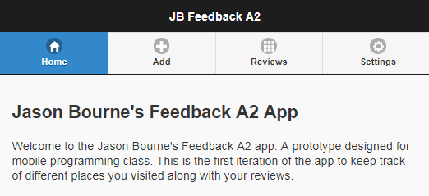

### Task 3: Modify ‘Add Feedback’ page

* Update the page by according to the following screenshot.
* Add a Type combobox containing Other, Asian, Canadian. “Other” will be shown by default.
* If ‘Do you want to add your ratings’ checkbox is checked then 3 rating textbox (Food Quality, Service, Value (Hint: input type=”number”)) and Overall Rating (Calculated (Hint: input type=”text”)) will be visible. Otherwise they will be hidden.
* When the page will be shown, ‘Do you want to add your ratings’ checkbox will be unchecked by default.
* Overall Rating textbox is readonly/disabled.
* Any change in the 3 rating text boxes will automatically update the overall Rating (calculated) textbox (Show average will follow the formula:
  + (Quality + service + value) * 100/15 .
  + Add a % symbol
* The 3 rating textboxes will be initialized with 0.
* Implement the show/hide feature in xxglobal.js file. Hint: put the 4 texboxes in a div, show and hide the div if the check box is checked/unchecked, respectively. See jQuery built in function show(), hide() (<https://www.w3schools.com/jquery/jquery_hide_show.asp>)

.

|  |  |
| --- | --- |
|  |  |

### Task 4: Update ‘Modify Feedback’ Page

* Update the ‘Modify Feedback’ page in the same way as ‘Add Feedback’ page.
* ‘Do you want to add your ratings’ checkbox will behave in the same way. Check the following screenshot(s).

|  |  |
| --- | --- |
|  |  |

### Task 5: Implement validation

* Include jQuery validation Javascript (available in eConestoga->Content->Resources->_lib.zip) in the index.html file
* Define your validation logic in xxutil.js file
* Add the following styles to xxmystyle.css file:

label.error{

color: #F00;

font-weight: bold;

}

input.error,

select.error,

textarea.error {

border: 1px red solid;

}

* Both ‘Add a Feedback’ and ‘Modify Feedback’ pages will have similar validation (defined in xxutil.js file). Hint: You need to implement a validation function for each form.
* The validation will get triggered when Save button (for Add Feedback page) and Update button (for Modify Feedback page) is clicked.:
  + Business Name: required and length must be 2-20 characters long
  + Reviewer Email: required and valid email address
    - Any valid email will be sufficient.
    - Making only conestoga email valid will result in deduction of marks.
  + Reviewer Date: required
  + If ‘Do you want to add your ratings?’ checkbox is checked
  + Food Quality, Service and Value: value must be 0-5
    - Note: don’t use min and max attributes for the ratings in the html file, rather define your own rules and messages for them in xxutil.js file.
* Check the following screenshot:

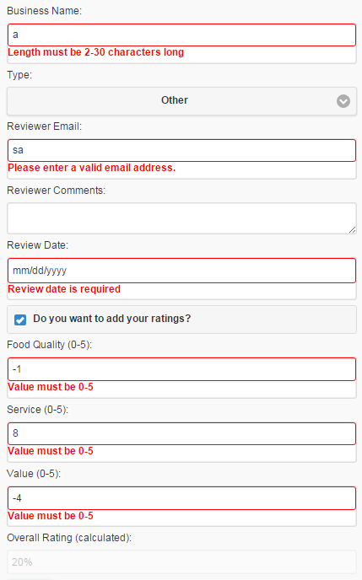

### Task 6: Update Settings page

* ‘Save Defaults’ button will save the ‘Default reviewer Email’ to local storage and show a message through alert.
* Use your own Conestoga email address as initial email when the page is shown.
* Check the following screenshots:

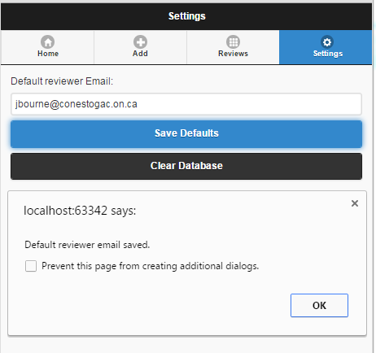

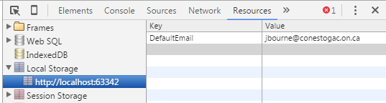

Hints: check LocalStorage.zip file available under Assignments module. See the script block to find out how to use localstorage.

### Task 7: Test your app

* Use Chrome browser and provide screenshots of the following
  + Home Page
  + Add a Feedback page with checkbox unchecked
  + Add a Feedback page with checkbox checked and with validation checked
  + Modify Feedback page with checkbox unchecked
  + Modify Feedback page with checkbox checked and validation checked
  + Settings page with alert (as shown above)
  + Developers tool containing Local Storage information (just like the screenshot above)
* Save your screenshots to xxA2Screenshots.doc file.

### Task 8: Upload app

* Make a zip file xxAssignment2.zip that will contain
  + Complete project for your app
  + xxA2Screenshot.doc file.
  + After unzipping, the application must run without any modification.
* Login to eConestoga and upload to the dropbox: Assignment 2.
* For late submission: marks will be deducted as specified in the coversheet.

### Task 9: Demo your app

* Demo your app on specified demo date. Please check the calendar available under “Course information”.
* Bring your hard copy during the demo containing:
  + Assignment coversheet and marking sheet
  + Printout of HTML File
  + Printout of xxglobal.js and xxutil.js
  + Printout of xxA2Screenshot.doc containing all screenshots
  + Assignment 2 marking sheet (The last page of this document)
* You must demo your project within 1 week of due date. Otherwise you will not get the marks allocated for demo.
* If you choose not to demo at all, you may drop the hardcopy of your assignment at WMB-4G26. However, if you don’t submit the hardcopy, marks will not be uploaded.

# Marking Sheet

|  |  |  |  |  |
| --- | --- | --- | --- | --- |
|  | Description | Marks Allocated | Marks Achieved | |
| 1 | Home Page designed as specified | 5 |  | |
| 2 | Add a Feedback page is designed as specified | 10 |  | |
| 3 | Add a Feedback page ratings show/hide | 10 |  | |
| 4 | Add a Feedback page validation (in Save button’s click handler) | 15 |  | |
| 5 | Modify Feedback page is designed as specified | 5 |  | |
| 6 | Modify Feedback page ratings show/hide | 5 |  | |
| 7 | Modify Feedback page validation (in Update button’s click handler) | 15 |  | |
| 8 | Settings page stores info to local storage | 10 |  | |
| 9 | 7 screenshots | 13 |  | |
| 10 | Overall ratings is updated automatically whenever any of the quality, service, value changes in add and modify pages. | 6+6 |  | |
| Deduction | | | | |
|  | Assignment Standard (proper project name, this marking sheet, etc., see the standard documents for detail) | 5 x ________ |  | |
|  | Prefix missing for id and name attributes | 2 x ________ |  | |
|  | id attribute is missing for any input control | 3 x ________ |  |
|  | name attribute is missing for any input control | 3 x ________ |  |
|  | JavaScript file and function name not prefixed | 2 x ________ |  |
|  | Programming Standard | 1 x ________ |  |
|  | Bug | 3-10 based on severity |  |
|  | Late | ­­_________days |  |
|  | No Demo | 50 |  |
| Total | |  |  |